Server problem. IP was changed from 51 to 52

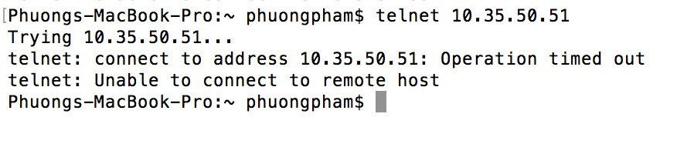

Tensorflow problem

1. Tensorflow was not running on GPU
2. Resource exhauted error (too many images to process?)

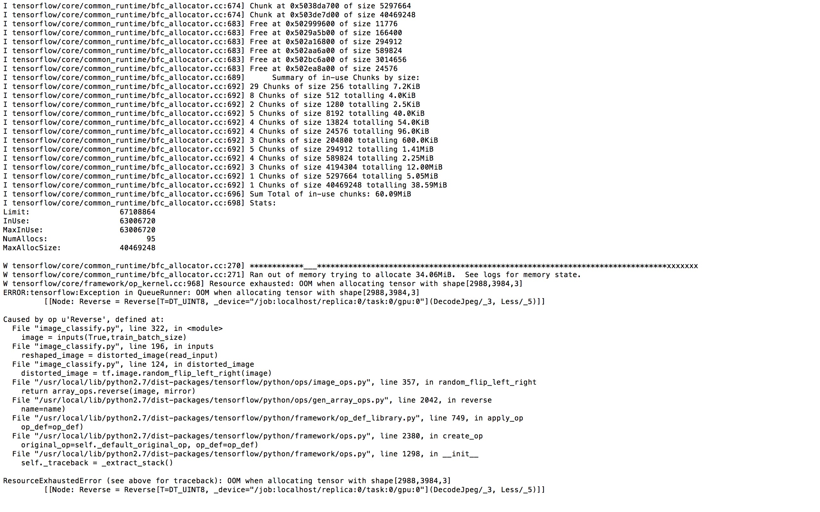

Torch

1. Memory leak issue: “you tried to allocate 0GB. Buy new RAM! at /root/torch/pkg/torch/lib/TH/THGeneral.c:210”

🡪 Changing the way to read the dataset

1. Data augmentation: brightness won’t change when applying brightness adjustment algorithm (ie. the pixel values displayed in your screen capture are all real numbers less than 1.0 suggests that the data you are working with here are not the original pixel values)

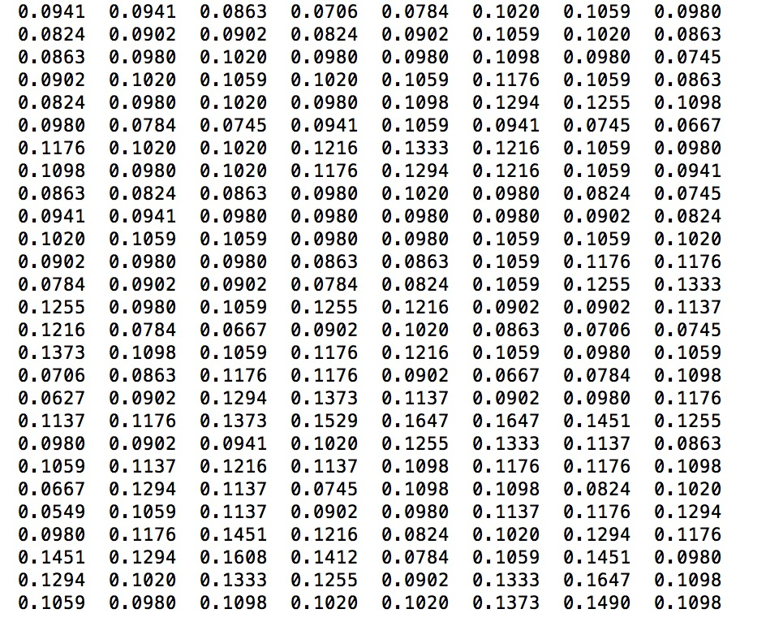

1. Learning rate: 0.001 🡪 CNN prediction is always in one class

Data:

* (good + avg + poor class) = original image

1. Learning rate: 0.005 🡪 CNN prediction is always in two classes (Good and Medium)

Data:

* (good + avg + poor class) = original image

🡪 data in Poor class is too little?

1. Best acc at the moment: 50.9%

Data:

* (good + avg class) = original image
* (poor class) = original image + center crop from orginal image (crop size 200x200)+ botom left crop from orginal image (crop size 200x200) + botom right crop from orginal image (crop size 200x200)

Learning rate = 0.005

CNN: Input (32x32x3) -> Convol layer (kernel size = 6x6) -> maxpooling (kernel size = 2x2) -> Convol layer (kernel size = 5x5) -> maxpooling (kernel size = 2x2) -> Convol layer (kernel size = 3x3) -> Convol layer (kernel size = 3x3) -> maxpooling (kernel size = 2x2) -> fully connected (2048) -> fully connected (2048) -> fully connected (3)

Loops = 100

Conclude: Data preprocessing is very important!

Results

